**TUTORIAL 6**

Image Processing

1. What is:
   * 1. Image enhancement?
     2. Image restoration?
     3. Morphological process
     4. Segmentation
     5. Object recognition
2. Based on figure 1 below, answer the following questions:

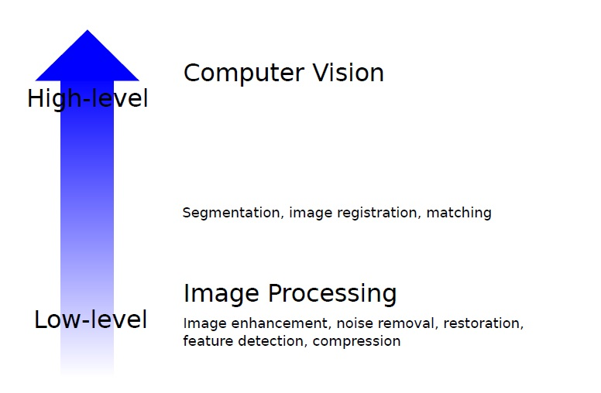

(ii)

(i)

Figure 1: Level of image processing

1. Name two (2) tasks involve under computer vision process.
2. What is the name of mid-level image processing?